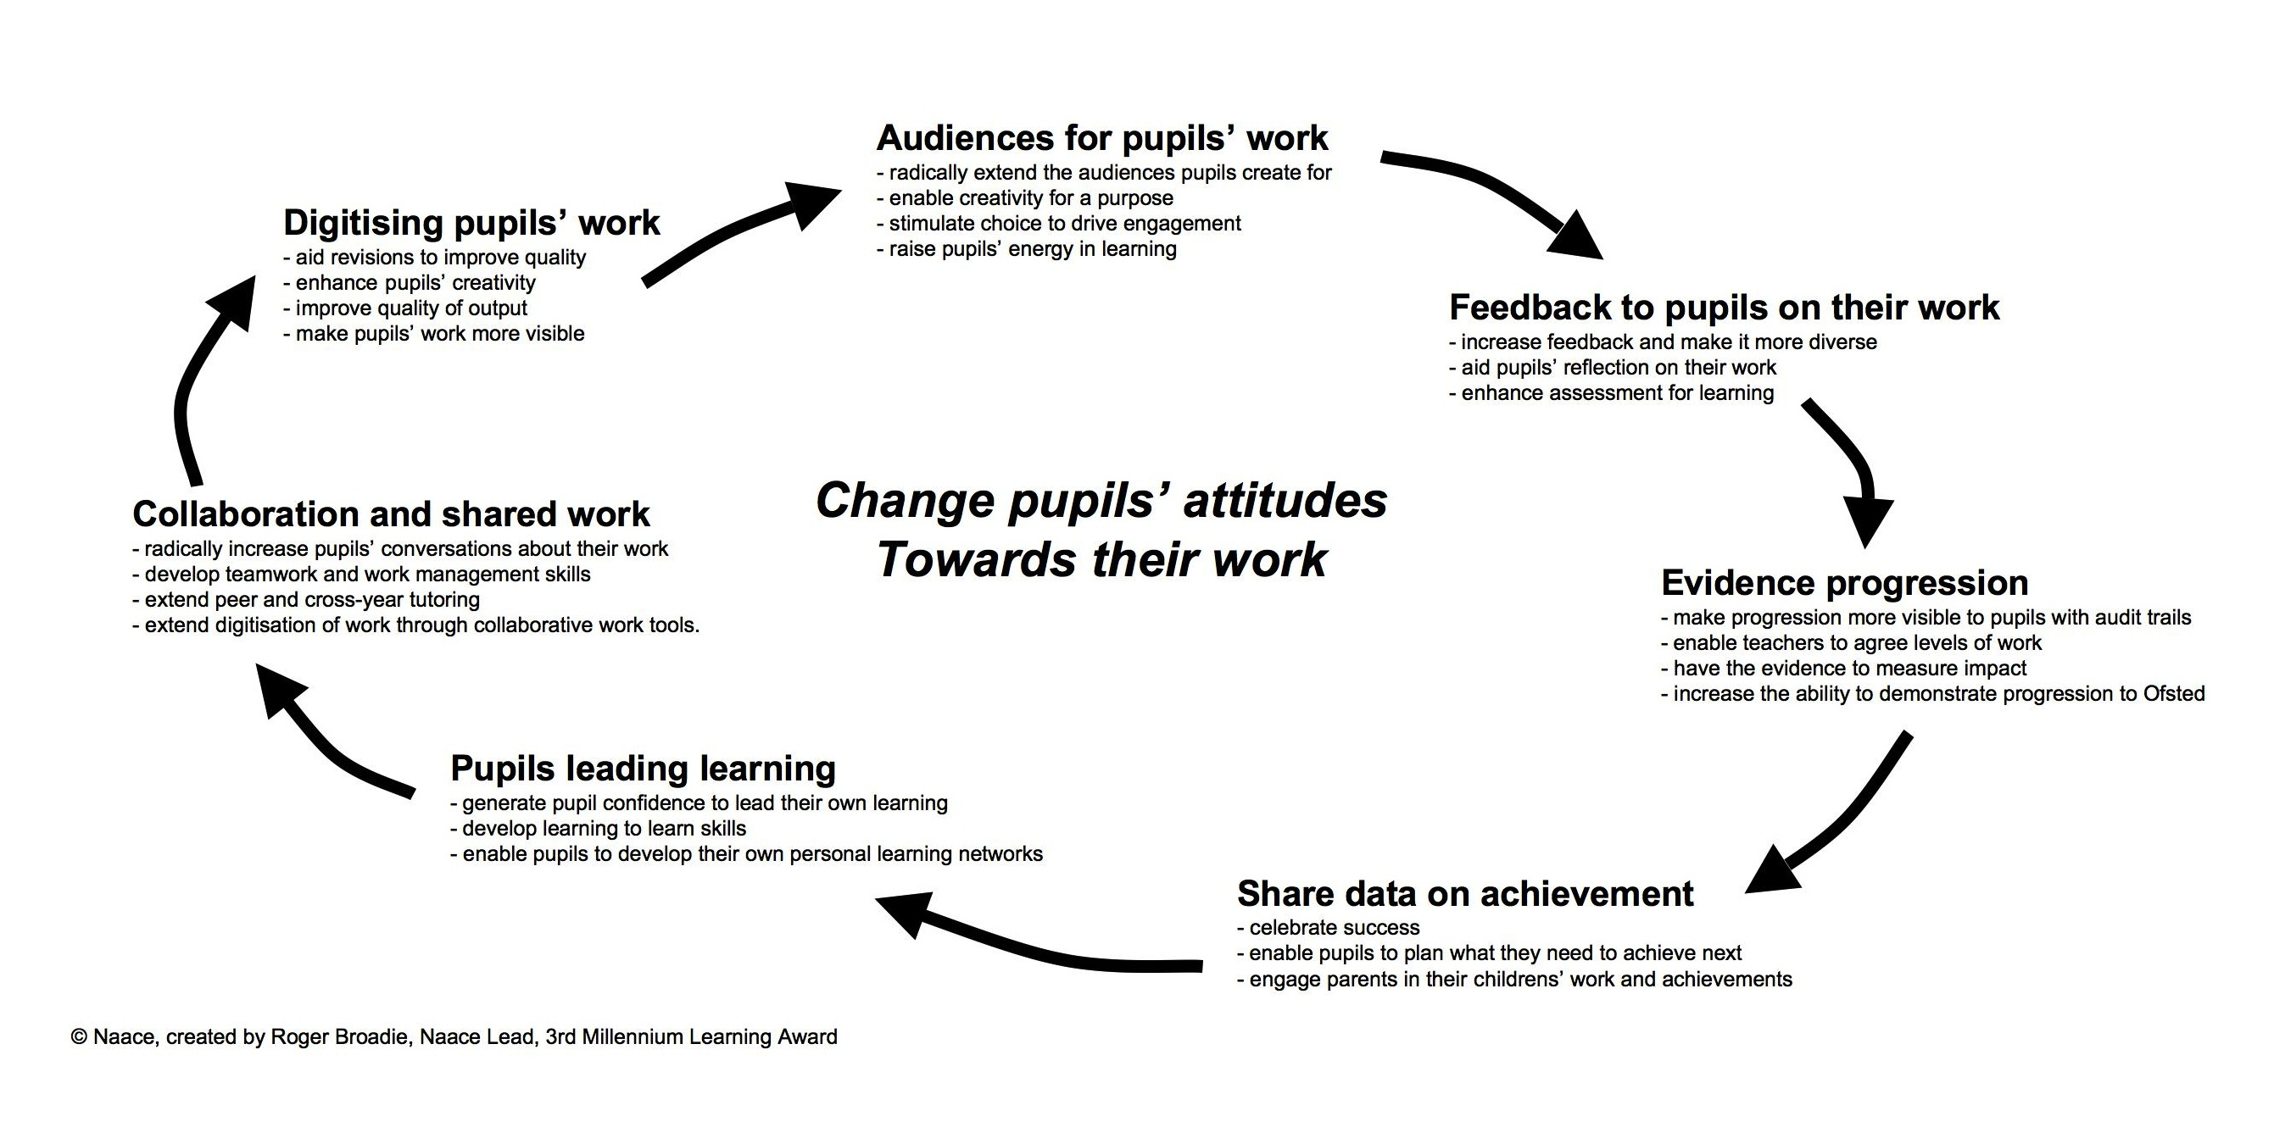

The virtuous spiral of improvement in schools.

Schools successfully transforming education actively build a culture where pupils:
- see failures as steps on the route to success and hence are happy to put their work in front of audiences and receive criticism
- believe their brain can be improved in the same way that their body can become fitter through exercise
- can clearly see and take pride in their progress
- and hence are happy to share data on their achievements, even if these are low relative to other pupils.

