C:\Users\ChrisS\SharePoint\Tools and supporting business - Doc\Naace logos\Naace Learning in a connected World - confirmed strapline 12.12.13\Naace Learning in a connected World.wmfC:\Users\ChrisS\SharePoint\Tools and supporting business - Doc\Naace logos\3rd Millennium Learning Award\3rd MILLENIUM LEARNING AWARD.wmf

The Naace 3rd Millennium Learning Toolbox

**4 – Impact section – Outstanding teaching and ICT**

Version – 2 July 2014

Introduction

School leaders know that outstanding teaching is critical to school improvement and many teachers want to be outstanding teachers. However the role of ICT in outstanding teaching is not well understood.

In the UK the schools inspectorate Ofsted has been slow to identify the importance of ICT use in outstanding teaching. There is a case to be made that where ICT is available teachers should be able to be described as outstanding teachers if they do not make use of it, as ICT can make the impact of their teaching very considerably greater.

The purpose of this tool is to forge a direct link in teachers’ and school leaders’ minds between the accepted definitions of what is required for teaching to be outstanding, and the use of ICT. The aim is to get these people to realise that while teaching can be outstanding without ICT, the use of ICT can multiply many-fold the impact of the approaches needed for teaching to be outstanding.

Use of the tool

The main part of this tool is an exercise for a group to do individually and then discuss. A time allocation of 15-20 minutes is sufficient. This exercise can be used as a lead-in to discussion of the technology priorities of a school in which case more time will be needed.

The exercise needs to be introduced which is best done with the Powerpoint slides that follow. The Powerpoint is available alongside these notes.

In preparation print copies of slide 3 for each person in the group.

i) Introduce the issue that many teachers do understand how ICT supports and enables outstanding teaching. This can lead them to ignore or marginalise ICT, or to use it in ways that have far less impact than is possible.

ii) Then show the Ofsted description of outstanding teaching (slide 2):

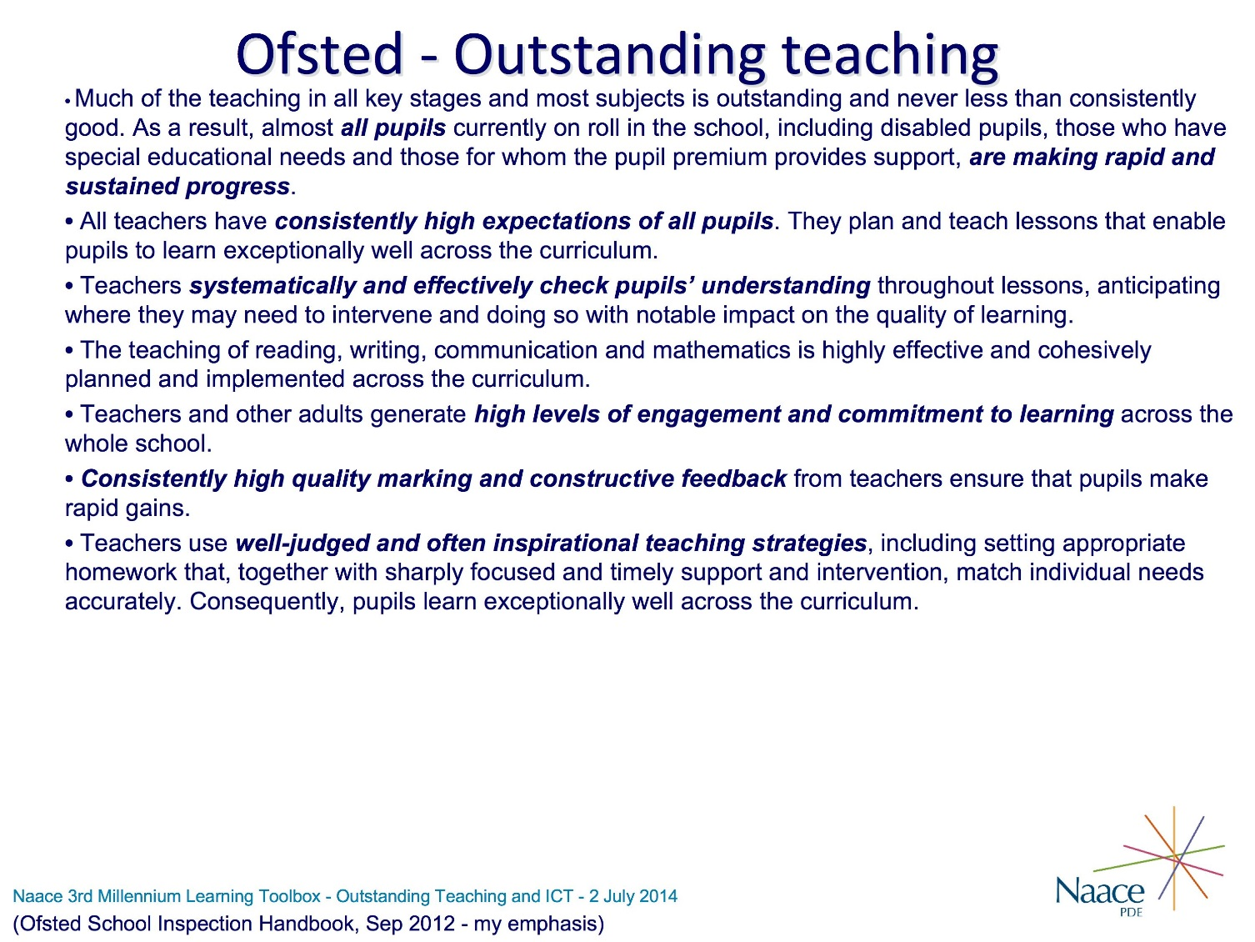

Check that they are familiar with this kind of description of outstanding teaching and are happy to work from this.

Explain that sections have been highlighted because the description is very wordy and if we are to see clearly how ICT can make outstanding teaching have even more impact we need to focus on the core of each statement.

iii) Proceed to the next slide which is set up to produce the outstanding teaching core statements on the first click and then to need a mouse click to produce each statement on how ICT impacts individually, so that you can talk about them as you display them. Display the left hand statements and check they understand that these are the key elements from the description of outstanding teaching.

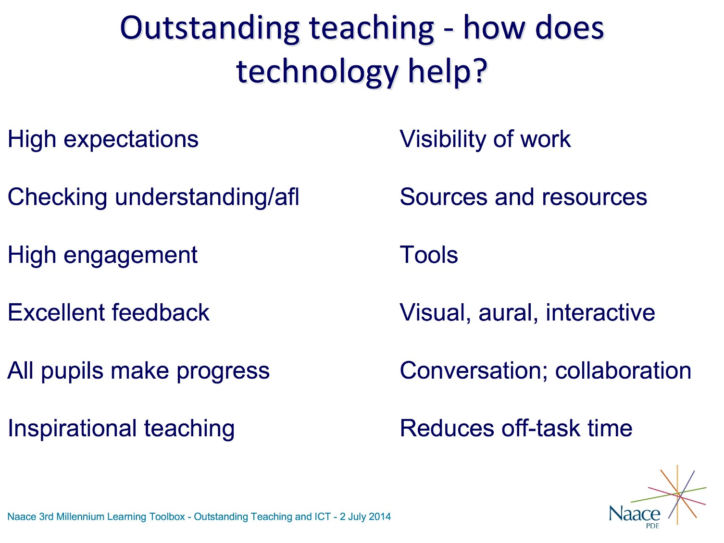

iv) Then tell them that you are going to list six key ways in which ICT has impact on teaching and learning. Explain each briefly as you display them:

- The visibility of pupils’ work is hugely increased when it is put online or displayed on the classroom whiteboard. It can be shown to many more people and it can be arranged for people to make comments on the work.

- The sources and resources available to pupils in doing their work can be vastly greater, with the whole of the Internet and in-school resources being made available, either by the teacher providing links or by the pupils finding them for themselves.

- The tools available are also vastly increased. Note that these may be tools to be used by pupils in doing their work but can also be organisational tools for pupils and tools that the teacher can use for classroom management and stimulation and engagement of pupils.

- Use of visual, aural and interactive approaches becomes very much easier to achieve, and some approaches that are just not possible on paper become possible. There is a lot that educators need to learn about how multimedia makes learning easier and better but there is a large amount of action research evidence from teachers to show that it does.

- Conversation and collaboration can happen in many new ways. They can be extended into out-of-class time, communication can be asynchronous as well as synchronous giving more thinking time, and collaboration can include working together using multi-user tools as well as discussion.

- Reducing off-task time may be because pupils are more engaged when using technology and concentrate better, but it can also happen in very small but important ways such as enabling instant look-up of information or of words pupils have difficulty spelling. These small bits of time saved not only add up to a considerable amount more time on the actual work, but also act to keep pupils in the flow of concentration, which can be seriously hindered if they have to break their flow of work.

v) Now tell them that you want them to do a little task by themselves, for which they will need a pen. Hand out the printed copies of the next slide, which is the slide you have just discussed re-arranged.

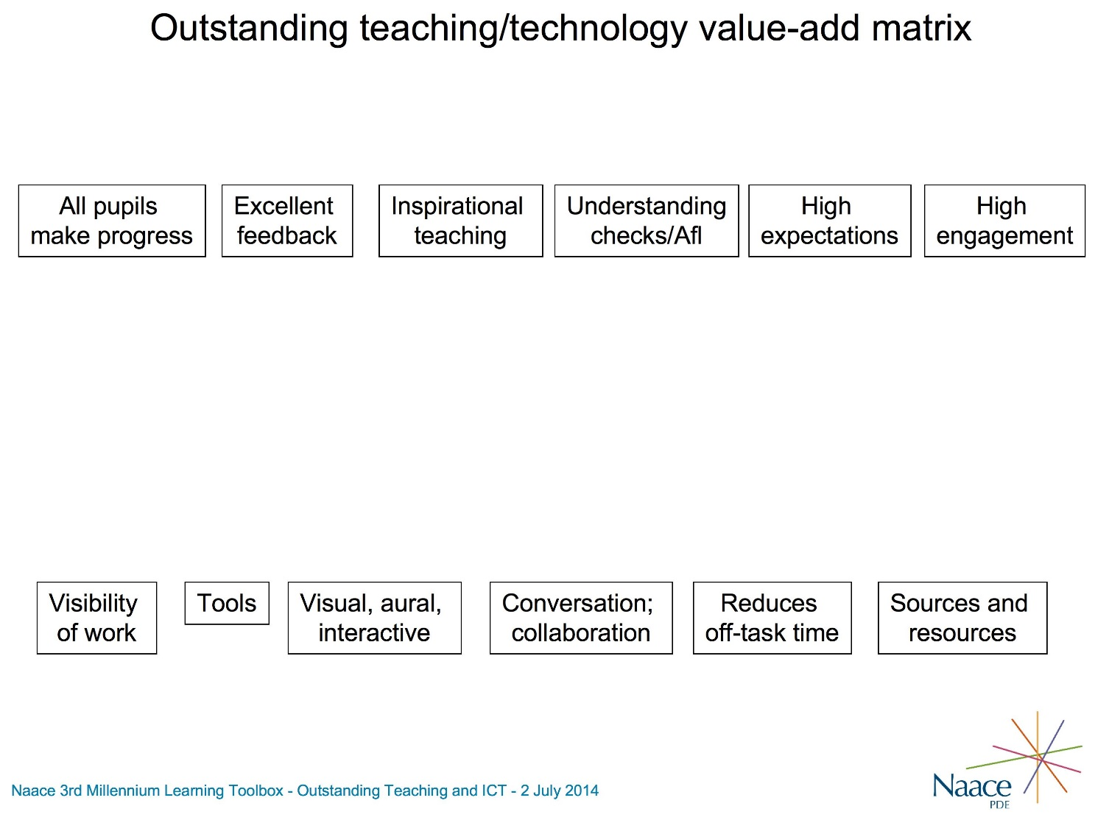

Tell them to think first about the bottom left impact of ICT, increasing visibility of work. Ask them to decide which of the aspects of outstanding teaching listed at the top this increasing visibility of work will support, and to draw rough lines from the visibility of work box to whichever of the outstanding teaching aspects it supports. And then to work along the bottom boxes and do similarly. If they hesitate stress that this is a quick exercise and all you are asking them to do is to think of some ways in which higher visibility of work might support the aspects of outstanding teaching. You could also prompt individually and suggest ways technology can support the aspects of outstanding teaching if anyone is slow to get going.

After two or three minutes suggest that they should by now be half way along the bottom boxes. After another minute or two, when the fastest have nearly finished drawing lines from all the bottom boxes, tell them that when they have gone right along the bottom boxes, they should count up how many lines they have coming out of each box at the bottom – and you will be asking them why they see that use of ICT as having more impact than the others.

vi) Their sheets will now be a mess of lines drawn all over the place. There is no need for everyone to properly finish and as soon as most have counted up bring them back into plenary. Go round the whole group and ask each person to state which of the bottom boxes they have most lines coming out of and to explain why they think that impact of ICT is the one that will have most impact on making their teaching more outstanding.

This round-robin discussion needs to be done fairly quickly, to get everyone to say something and just to get a feel for where their teaching emphases are. If any of the group have a particularly strong area relative to the other boxes it is worth exploring the reasons for this in a bit more depth, as it will help to show that different teachers are likely to get most impact from ICT in different ways.

vii) When used on the Exceptional Schools and TOTAL courses this exercise was used after the ‘Value-add from ICT in learning’ exercise. This exercise has similarities with that but provides a slightly different way of thinking about the ICT investment priorities for the school. To finish this exercise spend a few minutes pointing out that the ways the teachers in the school will provide outstanding teaching should strongly influence the school’s ICT priorities. If for example visibility of work is key, the school should ensure the online environments being used are properly effective for this; if access to resources and tools is key, the teachers need to be easily able to guide pupils to appropriate links by putting guidance pages online; if reducing off-task time is key the school should be considering devices for all pupils so that look-up and access to information can be instantaneous.

Credits.

The exercise was devised by Roger Broadie, Broadie Associates, Roger@BroadieAssociates.co.uk. It was then further refined during the Naace TOTAL leadership programme pilot courses, led by Tim Scratcherd and involving Julie Frankland and Penny Earl.

Background and further information

In the UK Ofsted has been very slow to link the use of ICT to outstanding teaching. They are still resisting making it a requirement for teachers to use ICT in order to be graded outstanding, on the basis that when they observe a teacher they might at that time not be using ICT. However they are now beginning to make statements that where ICT is well used in a school they expect outstanding teachers will be making good use of it.

The only place where Ofsted currently specify use of ICT, indirectly if not directly, is in their descriptions of outstanding teaching in different subjects, which can be found at http://www.ofsted.gov.uk/resources/generic-grade-descriptors-and-supplementary-subject-specific-guidance-for-inspectors-making-judgemen

Comments from Naace members in the Toolbox Preview Group on this tool and its use.

Comments from Naace members on this tool and its use are welcomed and will be appended here to help others gain maximum impact from use of the tool.